Milk Art

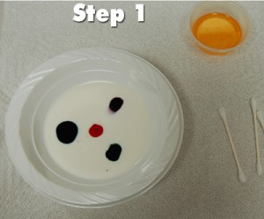
Materials
- A bowl
- ½ cup of milk
- Washing-up liquid
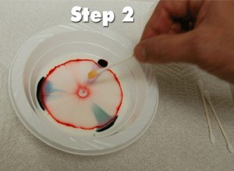
- Cotton swab
- Food Colouring, more than one colour if you can
- Pepper (optional)

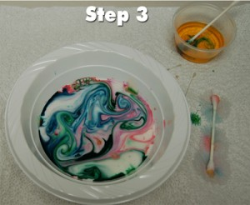
Instructions:
1. Pour the milk into the bowl. Be careful not to move the bowl, you want the milk as still as possible.
2. Put one drop of each colour in different places in the milk.
3. Put just a tiny amount of soap on the end of the cotton swab, then touch it to one of the colours. WOW!
4. Let the experimenting begin!
5. To clean up, just pour the milk down the drain. (Do not drink it)

How it Works:
Milk has fat in it and the food colouring floats on top of the fat. The fat is all connected with bonds. Think of it like the little pieces of fat all holding hands with each other. Washing-up liquid is used on greasy or oily dishes because it breaks the bonds in fats allowing them to separate. When you add the washing-up liquid to the milk, the fat separates and moves making your magical milk art!

Extra Experiments:
Does the temperature of the milk have any effect?
Sprinkle pepper on the milk before you add the soap, what happens to the pepper?

