1. Retrieve - What can you see? | 2. Infer – What do you think this book will be about?
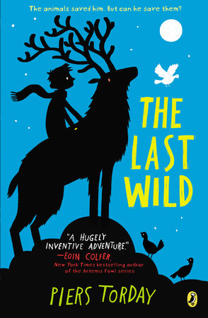  3. Predict – Do you think you will  like this book? Why? | 4. What questions do you have 0 about this book?

