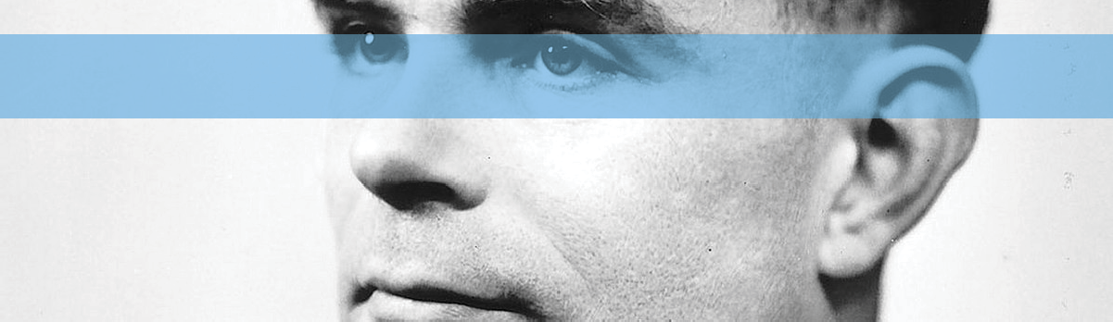
Alan Turing
Unit focus: British Innovators
Text focus: Biography (980L)
STAGE 6
*image courtesy of WikiCommons
Recently named the most iconic figure of the 20th century, Alan Turing was born in 1912 in London.
He was a studious child. When the country went on strike in 1926, he rode the 60 miles to school on his bike. From an early age, he showed a natural gift for mathematics and science. Aged 16, he not only read and understood some of Albert Einstein’s most complicated work, he even managed to explain some of the more hidden meanings.
While at school, Turing became close friends with a boy named Christopher Morcom. His death in 1930 caused Alan an incredible amount of grief. In response to this, he worked even harder at the subjects that they had both loved.
Eventually, Alan went to study at King’s College, Cambridge. While there, he came up with a design for a hypothetical computing device called a Turing machine. The idea behind these machines
was that they could compute anything computable. This design eventually formed the basis of all modern computers.
Leading up to the Second World War, Turing worked part-time in the government’s Code and Cypher School. This was a cover name for a government organisation created after the First World War to help break enemy codes.
When war broke out in 1939, Alan began working for the British government at Bletchley Park. The government had assembled an elite group of code-breakers at the Code and Cypher School, and many of these set about trying to solve the codes that Germany was using to send secret messages.
One of the most complicated codes that the Germans were using was called the Enigma Code.
It was while working here that Turing and his associates created a device called the Bombe. This device was based on work by brilliant Polish mathematicians who had started to work out how to decode parts of the encoded messages. Unfortunately, their method for decoding the messages

took a long time and relied on a weakness in the code. When the Germans found and changed the weakness, a new system was needed.
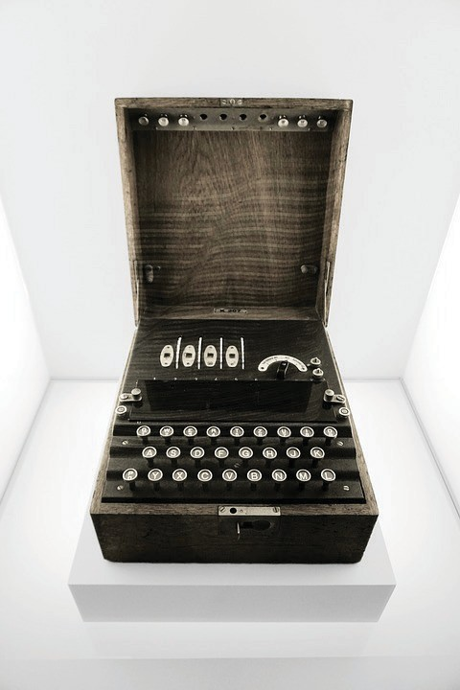
The design for the Bombe meant that they could decode Enigma messages even without the weakness. One of the other beauties of the Bombe machine was in its
speed: it dramatically increased the rate with which message could be read.

The Bombe machines weren’t small. Each one weighed a ton, was 7 feet wide and taller than a man. They contained over 10 miles of wiring and nearly 100,000 parts. The first machine cost nearly £4million in today’s money. It was worth it, though. It is thought that the work of Turing and the rest shortened the war by several years, saving many thousands of lives.

A German Enigma machine.

Unfortunately, Alan Turing’s life didn’t have a happy ending. He was gay, something that was illegal in Britain at the time. In 1952, he was arrested because of this. He never recovered from the
ordeal and died an unhappy man in 1954. When the British government decided to pardon all men convicted of “crimes” such as this in 2017, the law was named the Alan Turing Law in his honour
VOCABULARY FOCUS
- Which word or phrase means that Alan Turing enjoyed learning and school?

- Find a word or phrase that shows how Alan Turing felt when Christopher Morcom died.

- What does the word “associates” mean?

- What does the phrase “shortened the war” mean?

- What does the word “beauties” mean in this context?
P
S
E
What happened once the Germans discovered the weakness in the Enigma code? In the final paragraph, why has the author used quotation marks around “crime”? What were the two key things about the Bombe machine?
Why do you think the Bombe device helped to shorten the war?
S
VIPERS QUESTIONS
Where were the mathematicians from who started cracking the Enigma code?
R

