|  |
| --- |
| Tell The Time 31cm Wall Clock Multi Multi Coloured  30.6.2020  **Measurement**  **Focus**: telling the time to o’clock and half past |

Mr Grinling goes to work at

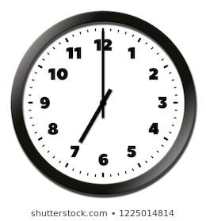



____________________________

He starts work at

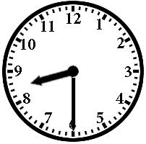

__________________________

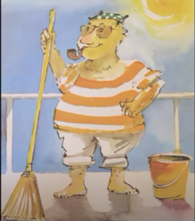

Mrs Grinling sends his lunch at

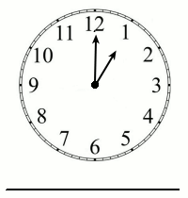

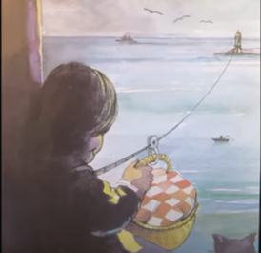

_________________________

Mr Grinling goes to bed at

_________________________

