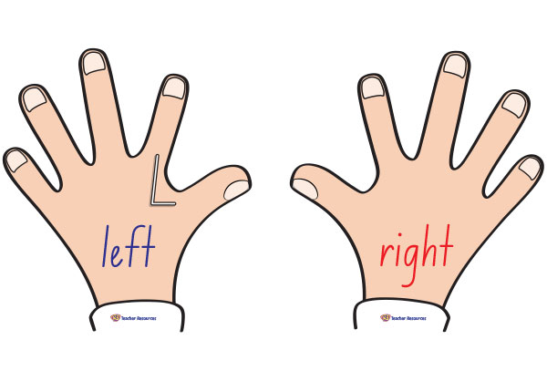
1.7.2020
Position and Direction
Focus: describing position

In today’s lesson we have been outside and used the words left, right, quarter turn, half turn, three quarter turn and full turn to describe direction.
We linked the practical work to the book The Lighthouse Keeper’s Lunch.

Extra Challenge
