1. Retrieve - What can you see?  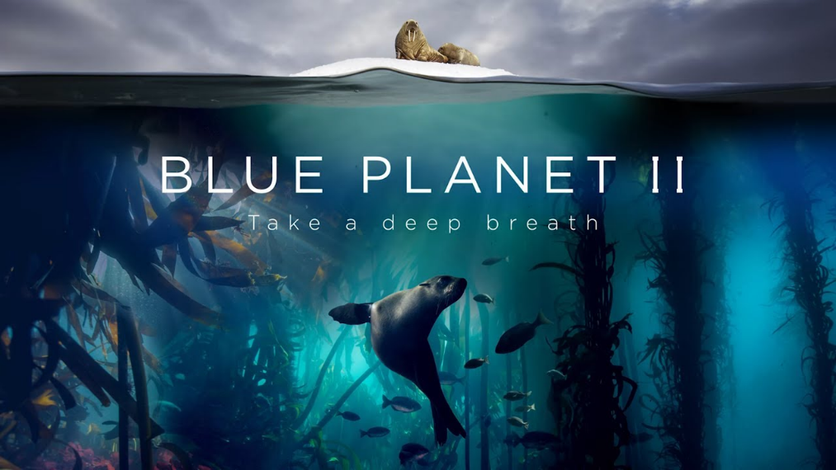 | 2. Infer – What do you think this TV show will be about?
3. Predict – Do you think you  will like this show? Why? | 4. What questions do you have 0 about this TV show?

