- What do you think will happen next?  - How the boy might have ended up at Spectrum Hall Academy for Challenging Children?  - Why do you think there might need to be a Quarantine Zone?  - What do you think might happen in this book?  Write a book review using the template. | 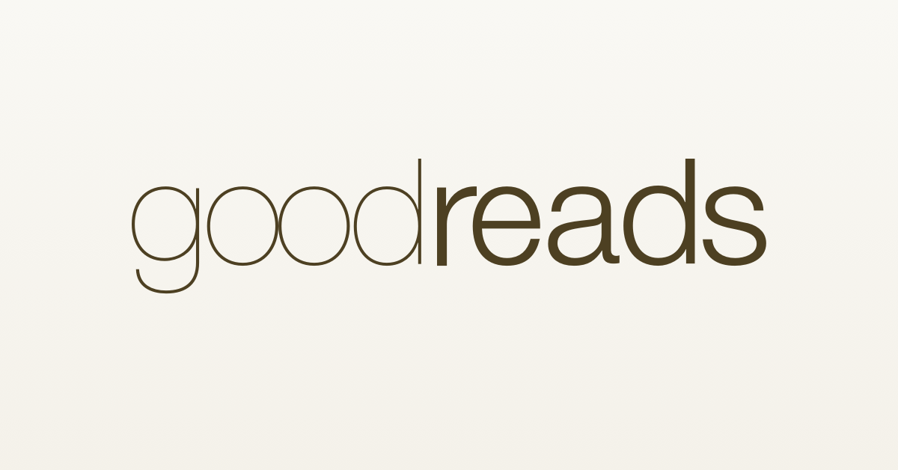  Title:______________________________________________________  Author: _______________________________________________________  Theme/Topic: __________________________________________________  Age Range: 4 or below 5 – 7 7 – 9 9 – 11 11+  Summary of Opening: ____________________________________________  ______________________________________________________________  ______________________________________________________________  ______________________________________________________________  Why I want to read on: __________________________________________  ______________________________________________________________  ______________________________________________________________  ______________________________________________________________  Rating:

